Copying the data set from local to HDFS using Flume agent

Flume cong file:

Path: /etc/flume-ng/conf/flume.conf



Start flume agent by the following command**:**

flume-ng agent -n agent -c conf -f /etc/flume-ng/conf/flume.conf

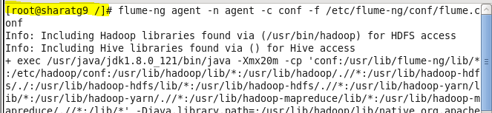

This will conform the agent is running and we can leave this terminal running at background

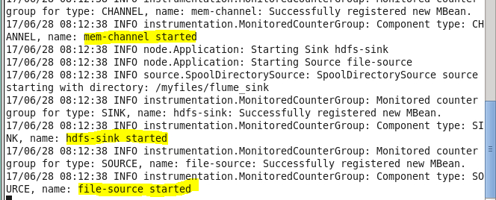

As mentioned in flume configuration file TitanicData.txt is pasted inside flume_sink directory

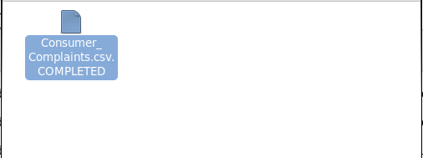

We can now check the resultant temporary file inside HDFS at destination path generated by Flume. By the listing command we can find only one file inside **HDFS /flume_sink.**

